OVERVIEW

Phase 1: Learning Goal & Content Generation
The system initiates personalization once the user enters a Learning Goal.
LLM1 (Categorizer): Defines the domain and branch based on the goal.
LLM2 (Architect): Generates the Knowledge Base, Chain-of-Thought (CoT) prompts, RAG data, and few-shot examples.
LLM3 (Reviewer): Validates and reviews the contents generated by LLM2.
LLM4 (Example Generator): Creates specific reference examples for the user's self-assessment.

Phase 2: Self-Assessment Framework
Users perform a self-assessment by defining a problem and providing details across four dimensions:
Facts: Basic definitions and phenomena.
Strategies: The high-level approach to solving the problem.
Procedure: The specific step-by-step process.
Rationales: The deep reasoning behind the chosen procedures/strategies.

Assessment Logic & Labeling
The system evaluates the user's input against the LLM-generated knowledge base using Few-Shot Calibrators and CoT Checklists.
Label Glossary: * Know-know (Correct)
Know-don't know (Admitted gap)
False knowledge (Incorrect)
Omission (Missing info)
Irrelevant knowledge (Off-topic)
Output: A Self-Assessment Report identifying the student's Most Critical Gap. This report is stored in the database and fed into the active session.

Phase 3: Chatbot Implementation
The interaction phase utilizes a dual-LLM setup:
LLM1 (Tutor): Responds directly to student questions.
LLM2 (Evaluator): Continuously monitors and checks the student's understanding throughout the conversation.

DESIGN APPROACH

Step 1: Generate Self Assessment Form
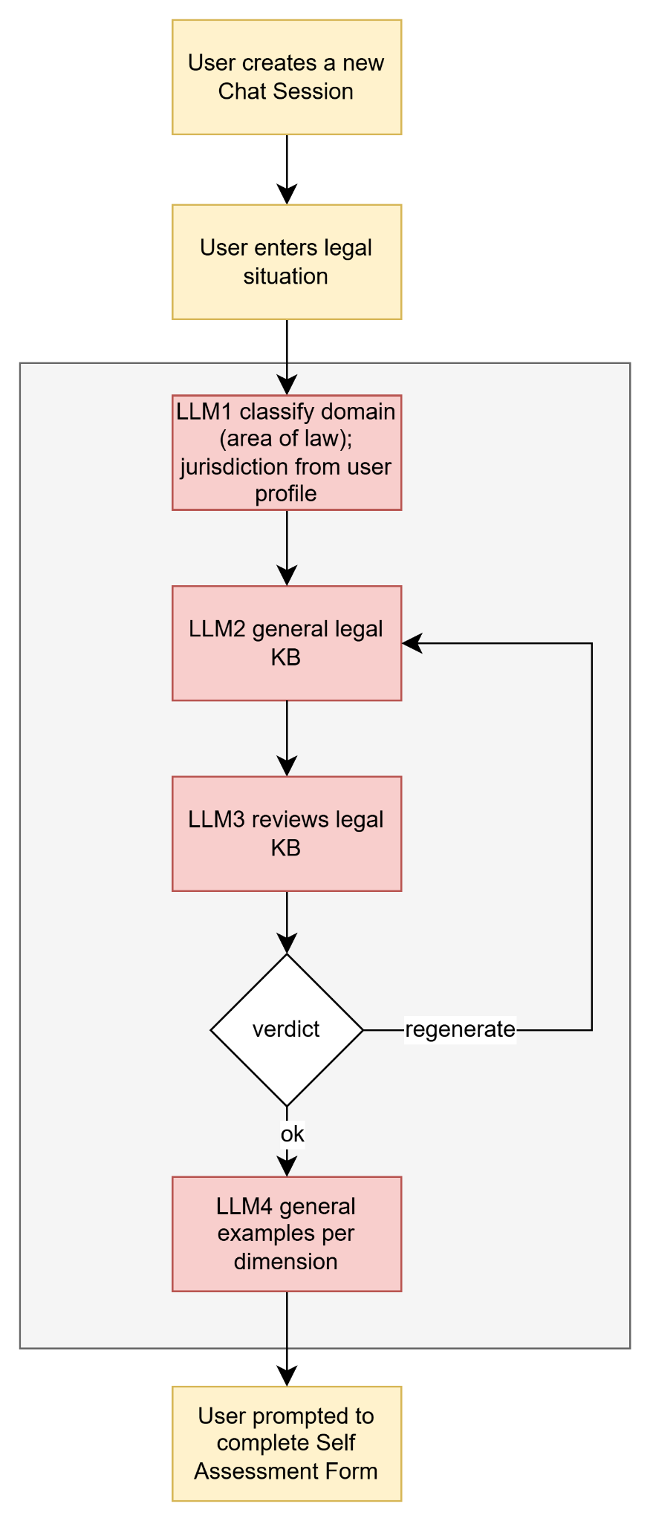
Notes:
- Legal-specific KB
- KB key=legal_domain/jurisdiction e.g. traffic_law/texas
- Change the academic domain taxonomy (mathematics, science, CS) with legal-specific domain taxonomy (traffic law, contract law, tenant rights)
- We do not generate branch from user’s goal but user jurisdiction (available in our user profile from during onboarding)
- Legal KB expiry/refresh policy
Self Assessment Form - Example 1
- Problem Statement: I got a speeding ticket doing 80 in a 65 zone on the highway last week
- Facts: What the user understands about their legal situation
I know I was doing 80 in a 65 zone. I got a citation with a court date on it. I think the fine is around $200.
- Strategies: What options does the user think he have
I think I can either just pay the fine online or go to court and fight it. I've also heard about defensive driving courses.
- Procedures: What process does the user think the situation involves
I think I log into the county website and pay, or I show up on the court date if I want to contest it.
- Rationales: Why the user prefers this approach
I want to take a driving course to keep the ticket off my record

Self Assessment Form - Example 2
- Problem Statement: I want to understand this contract document that I have uploaded
- Facts: I know it's a service agreement between me and a freelance contractor. It mentions payment terms and a 90-day notice period. I'm not sure what 'indemnification' means or what I'm actually agreeing to in that clause.
- Strategies: I think I can either sign it as-is, ask for changes to certain clauses, or refuse to sign altogether.
- Procedures: I think I just read through it, flag anything confusing, and then sign it if I'm happy
- Rationales: I want to understand it fully before signing because it's a long-term engagement and involves a large payment.

Step 2: Evaluate Self Assessment Form
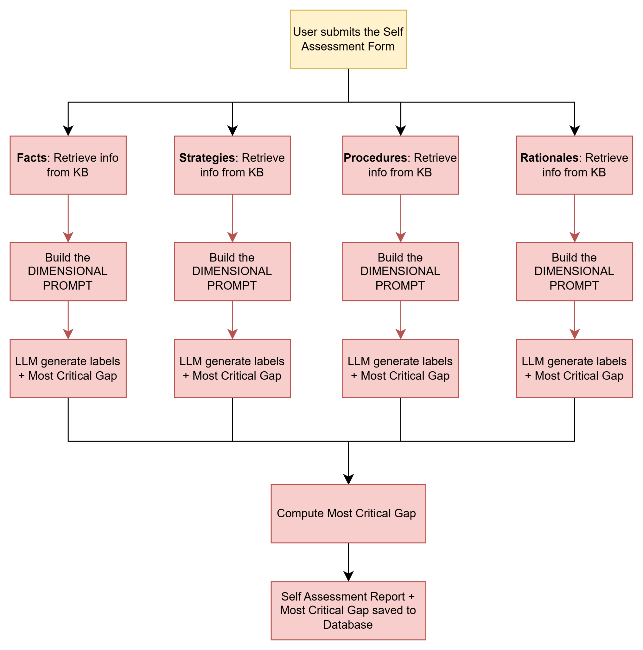
Notes: Token-overlap RAG scoring will be a limitation of legal language

Step 3: Using Self Assessment Report
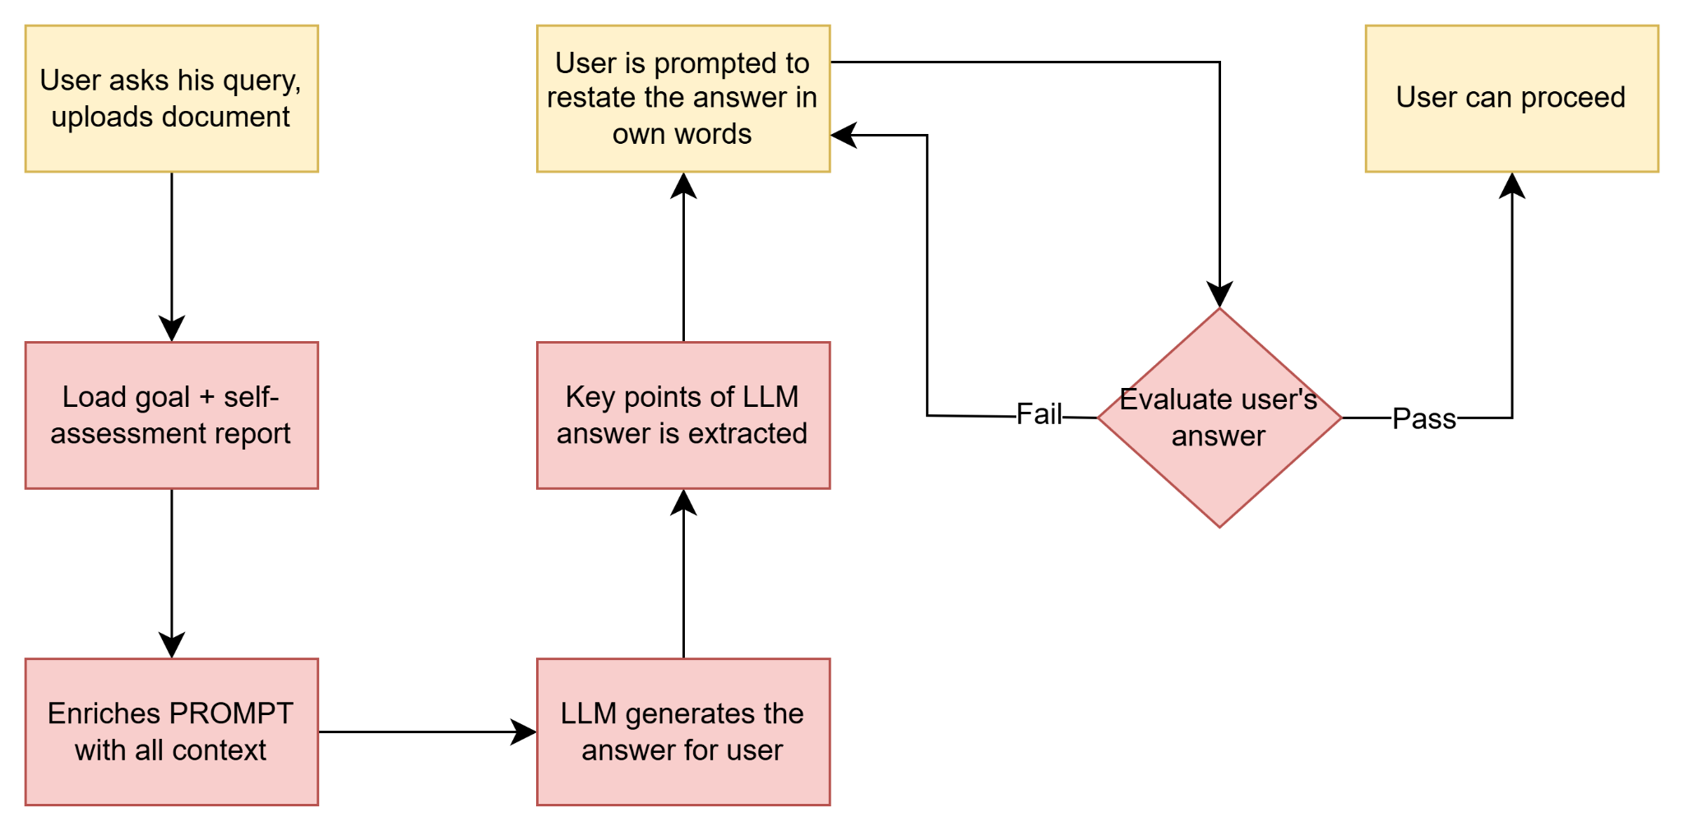

Limitations
- Current RAG is token-overlap based, not semantic.
User: I want to contest the ticket because I don't think the radar gun was accurate
KB: A defendant may challenge a speed measurement device by requesting calibration records and maintenance logs for the equipment used during the stop.
- The Knowledge Base for Legal Data can be outdated
- Self-assessment assumes user awareness but general public answers might not be meaningful
Law Student: I want to negotiate the indemnification clause because it creates unlimited liability exposure for me, and I believe the IP ownership clause should be amended because it assigns work-for-hire rights too broadly.
Random User: I don't really know why, I just need to sign it for work
- Cross-jurisdiction: federal vs state law, what if the user moved and it concerns multiple states -
  - ask the user,
  - clarifying questions along with answer from LLM
  - predefined set of questions to gather the information he needs to answer the question (if known situation) otherwise LLM generates

Proposal for Legal Use Case
- Conversational intake instead of Goal Input:
  - What is your situation? -> understand legal problem
  - Have you dealt with this before? -> understand baseline familiarity
  - What outcome are you looking for? -> understand intent
  - Does your situation involve more than one state or country? -> flag for cross-jurisdictional
- Migrate from LLM-generated RAG evidence to real legal sources
- Time-based expiry policy for the LLM-generated knowledge base (30 days)
  - Out-of-scope for now
  - cost analysis
  - how often do laws change (like statues)

